Computer Language, Flat & Structured Interchange

Methods & Classes Loosely Coupled
In C++ a method of a class automatically becomes a global method as well. The first argument of the global method, is the object the method is called upon. This is called the this-argument. If the global method has more parameters, that are objects, those objects’ public members are accessible from within the method. Of the this-argument, the global method can access the private members as well.

Method not part of class definition
A bold statement, emphasizing total interchangability of global methods and class methods:

Any method that takes an object as an argument, becomes a method of this object’s class.

A parameter adds the method to the class of the parameter.

This makes it so that the very same method can be part of several classes. This makes methods independent entities, that are not tied to a class.

When you add a parameter to a method, the method is automatically also added to the class of that parameter. You don’t even have a say in that anymore. That’s just the way it is.

The principle methods & classes loosely coupled can also be called: procedural and object oriented interchange, because instead of viewing methods as part of classes, you can also view them as a flat list of methods.

You shouldn't see the method as being directly part of the class. The methods just seem to be part of the class. In object oriented programming, methods also just seem part of an object, while they are really only defined in a class. In Computer Language methods are not even part of a class. They just seem to be part of a class.

When you program a method, that does something, the action is immediately available in the context of any type of object, that has anything to do with that method.

All this time, the software development community has fought for making methods part of a class, instead than having a flat list of global methods. And here I claim the opposite. Like it is a step back in the development of computer programming. But this system doesn’t pick either side. Methods are both independent entities as well as part of a class. This system makes flat and structured completely interchangable.

Calling a method on an object
A method can be called on each object, whose class is a parameter of the method.

<>When you call a method on an object, the object is not visible as part of the parameter list anymore. The other objects still need to be filled in as parameters.<>

Method’s access to private contents of classes
The this-argument in C++ was special: the method has access to the the private contents of the this-argument.

The fact, that you can access the private contents of a methods is a special setting. The fact, that you can access the private contents of a methods is determined inside the class definition, not by the method itself. A class grants a method’s access to its private contents. This makes the method more part of the class, but a method is still a separate entity, that can apply to multiple classes.

Private members of a class are useless, unless there are methods that use these private contents. So the informal connection between classes and the methods, they grant private access to, is very tight, and those methods are actually the protectors of that class’s private contents.

Classes giving methods access to their private contents is formally a form of access control. But informally the methods that have access to the private contents of a class, are the protectors of that class. The class appoints these protectors. Methods do not decide to become such protectors on their own.

Local variables
Local variables, as they are called in contemporary programming languages, are a lot like parameters. Unlike parameters, they are private to the method, rather than publically written or read. Local variables are private contents of a method. Since they can not be publically set, and you can not determine what object the private variable will hold, the method also can not become part of any arbitrary object. So the classes of local variables do not add the method to those classes. <>

Methods with fixed logical residence
A class’s granting a method access to its private contents, creates a tight informal bond between the class and the method. The method becomes part of the class in a way, even though a method still is a separate entity. Another way to make a method part of a bigger whole, is to give a method a fixed logical residence. A method already has a fixed physical residence, namely: the place where the method is stored on disk permanently. A method is stored somewhere, just like an object. But a method can also be given a fixed logical residence. This fixed logical residence shadows the fixed physical residence and gives a method a fixed logical position. The logical residence of the method is the target of all references to the method. Only the fixed logical residence has access to the physical residence of the method.

It is actually advised to give a method a fixed logical residence. Preferrably, make it part of a module, because modules will bundle together classes and methods to a single logical unit of functionality. Don’t make the method part of a class. This binds a method too much to a class. Give a method the ability to become part of multiple classes, rather than tying it up to a single class. A class’s granting a method access to its private contents already establishes this bond, and the method will be visible as part of the class. You don’t need to give the method a fixed logical residence inside the class to establish that.

Automatic containment of methods
Methods can be used in arbitrary places, just like objects. In the article about automatic containment, for objects it is extensively discussed, how that makes objects logically part of multiple wholes. However, a single logical residence of the object was appointed, that is the real residence of the object itself, while all the other locations, were mere references to the object. Also: from the perspective from which you looked at the object structure, a single logical location within view was appointed to represent the object itself, even though the real location of the object was out of sight.

It works the same for methods. A method has a fixed physical location, where the method is physically stored on disk. This physical location is usually shadowed by a fixed logical location, which is the logical target residence of the method. The fixed logical location usually resides directly inside a module. Any pointer to the method directly or indirectly points to the logical target location of the method. However, when the target location of a method is out of sight, a single location is appointed to be the intermediate, imaginary target of the method references.

A reference to a method is either a method invokation, or an inactive pointer to the method. For now only method invokations are considered, also called method calls.

In this story, I will first make methods totally independent entities, not tied to a class at all. A call to a method contains parameters, to which objects need to be assigned. This is done by tying each parameter to an imaginary reference to the object. The method call will simply contain object references pointing outward to imaginary references.

The method call symbol itself, will point to the closest imaginary reference to the method. The method call symbol will be connected to the closest imaginary reference with a class line (a dashed line), because the method symbols will represent the same class of method, not the same instance of the method.

The automatic containment of methods has one particular difference with automatic containment of objects. Imaginary references to objects are not show in the diagram, unless the object is actually used in that part of the diagram. Methods are shown in the diagram, even if they are not used in that part part the diagram. Imaginary references to methods are shown inside each object that has a class, that the method uses as one of its parameters. The imaginary references to methods, that are put inside objects, are there, even when they are not used in that part of the diagram. That makes the method available from any object, that could be used by the method. That is a good thing. All methods, that operate on the object are directly available from that object.

Now I will explain, how you create a method call in the programming environment. A method call is created inside another method. You first create a method call, with no particular method assigned to it yet. Next you tie the method call to a particular method. This method resides usually inside an object. You tie the call to the method inside an object. After you’ve done this, the diagram transforms. You, the programmer, tied the call to a method inside an object. The system under the surface ties the method call to the actual method definition, which could be far out of sight. After that, the method call is imaginarily tied to the method definition through imaginary references, that eventually lead to the method definition. The method call contains pointers to the arguments, which means, that the line, tying the call to a method inside an object, is now replaced by an object reference inside the call that points to the object. The imaginary method reference inside the object isn’t even pointed to anymore. It just sits there, just as an imaginary reference, that nothing is tied to, just to see what actions you can perform on the object and what you can make the object do. The object simply says: “Hello, this is what you can do to me.” . The object methods do point to the method definition through imaginary references, but nothing is pointed to it anymore. After that, the diagram is transformed even more: the parameter might not point to the object symbol you first called upon anymore: it now points to the closest imaginary reference to the object, which may not be the object symbol you used to establish the call to the object at all.

I will repeat the story, but now with pictures of diagrams in between.

A method call is created inside another method:

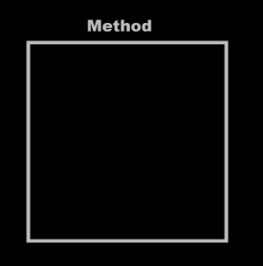 | → | 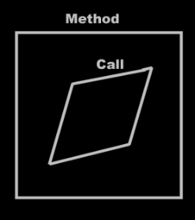
First you create a method call, with no particular method assigned to it yet. Next you tie the method call to a particular method. This method resides usually inside an object. You tie the call to the method inside an object.

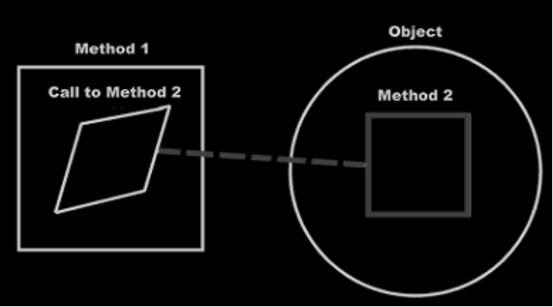

Method 1 now calls Method 2 of the object.
After you’ve done this, the diagram transforms. You, the programmer, tied the call to a method inside an object. The system under the surface ties the method call to the actual method definition, which could be far out of sight.

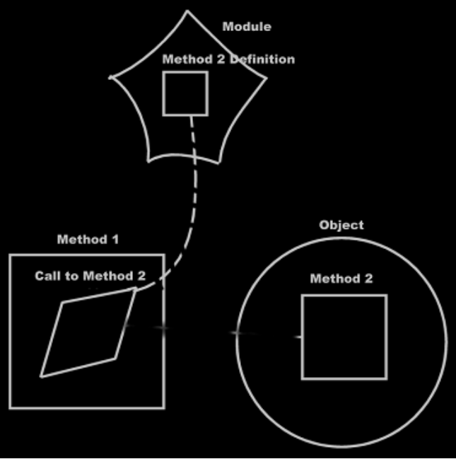

After that, the method call is imaginarily tied to the method definition through imaginary references, that eventually lead to the method definition.

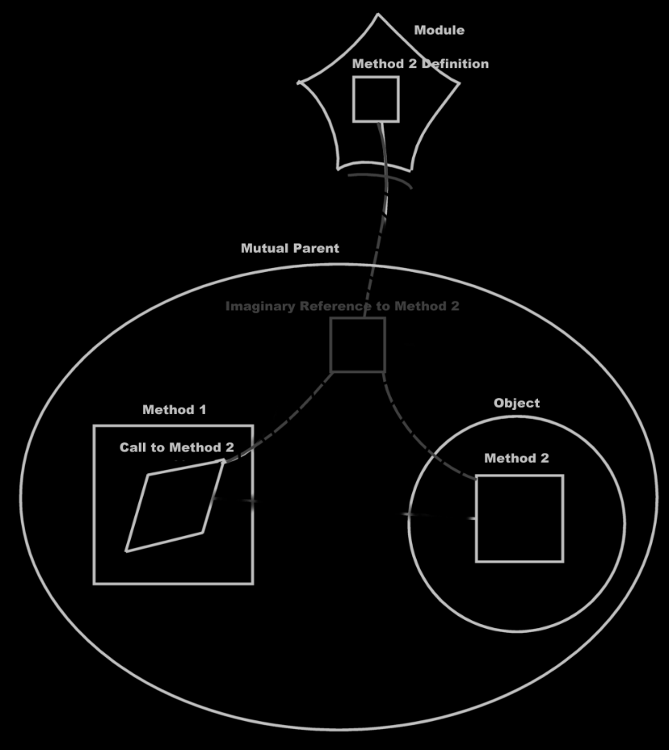

The method call contains pointers to the arguments, which means, that the line, tying the call to a method inside an object,

is now replaced by an object reference inside the call that points to the object.

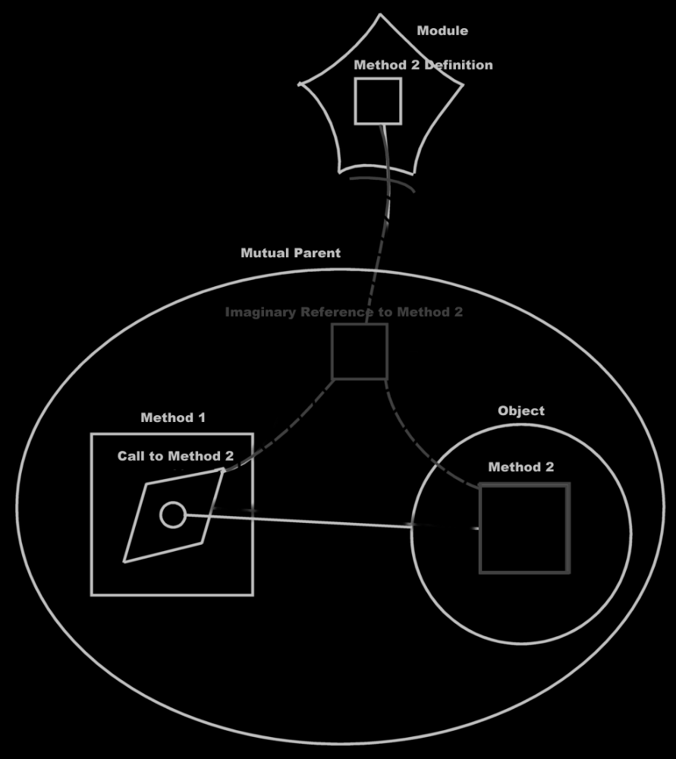

The imaginary reference inside the object isn’t even pointed to anymore. It just sits there, just as an imaginary reference, that nothing is tied to, just to see what actions you can perform on the object and what you can make the object do. The object simply says: “Hello, this is what you can do to me.” The object methods do point to the method definition through imaginary references, but nothing is pointed to it anymore. After that, the diagram is transformed even more: the parameter might not point to the object symbol you first called upon anymore: it now points to the closest imaginary reference to the object, which may not be the object symbol you used to establish the call to the object at all.

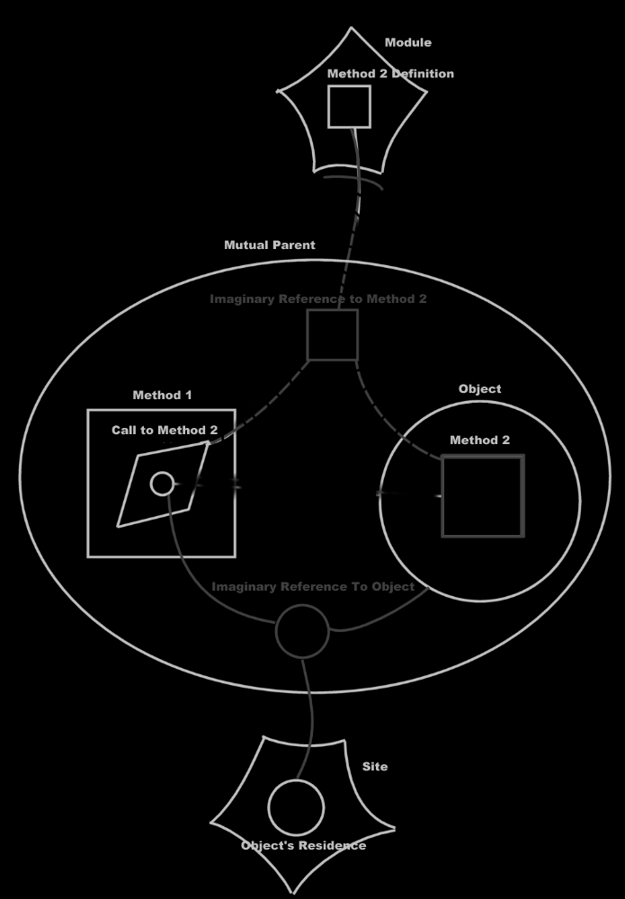

So really, this:

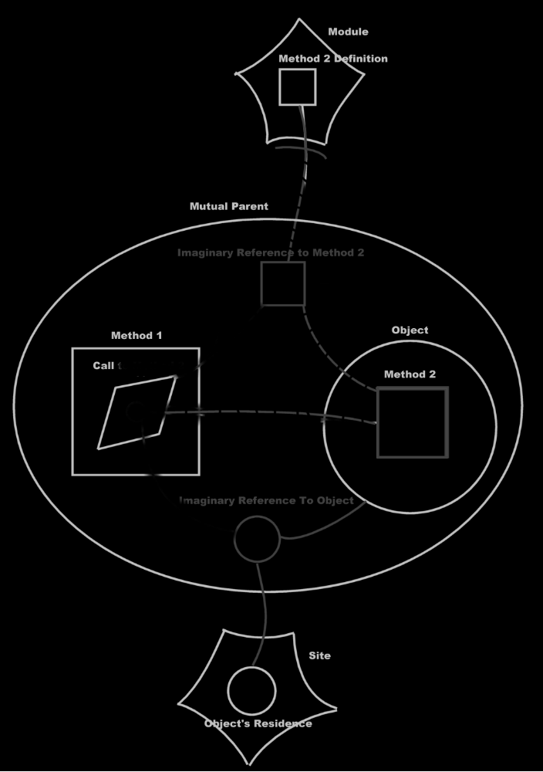

Turns into this:

When you get used to reading the diagrams, you will clearly see that you are calling a method of a module, passing an object on a site to it as a parameter. You also see that nearby there is a reference to the same object, that contains an imaginary reference to the method.

But what you don’t see, is that you are calling a method of an object. That’s what still sucks in this notation.

It’s like the call to an object’s method is replaced by a call to a global method, passing the object as a parameter. But you want it the other way around: you want a call to a global method to be displayed as a call to an object’s method in the clearest possible way. The flat and structured interchange principle methods & classes loosely coupled should be called automatic class methods, or something.

It should be the other way around: the last picture should turn into the picture before that automatically, and that should be the automatic coupling of the object and the method call.

< Brainstorm 3, expressing a call to method as a call to multiple objects >
Yesterday, when I was lying in bed, I thought: when I have to express that a single method is called upon two objects, I have to tie the method call to both objects' method definitions.

So it would be a call to both objects' method. Instead of referencing both objects from the method, the method is tied to both method references inside the objects.

The diagrams shown before, the expression of calling a global method, with its object as a parameter, turned out to be exactly how I didn’t want to express it.

In this brainstorm I want to display calling a remote method with two remote objects as parameters. And then calling a remote method on both those objects. It’s basically the same example as above, but now with two parameters. I am trying to find out how to best express a call to a method, that is part of multiple objects. I am trying to find out, if the way of expression I have in mind, will adequately express calling upon multiple objects to execute the same method.

Call to a global method with two parameters:

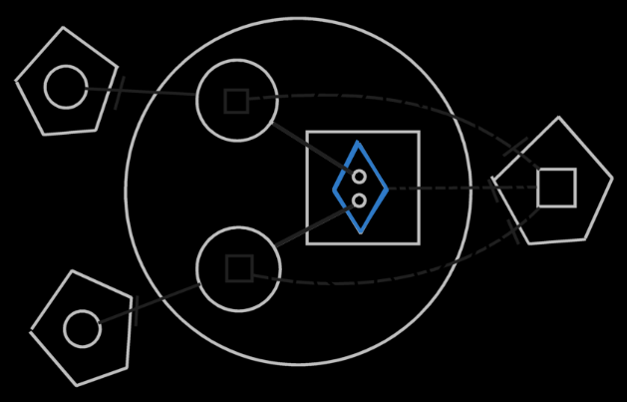

Call upon two objects:

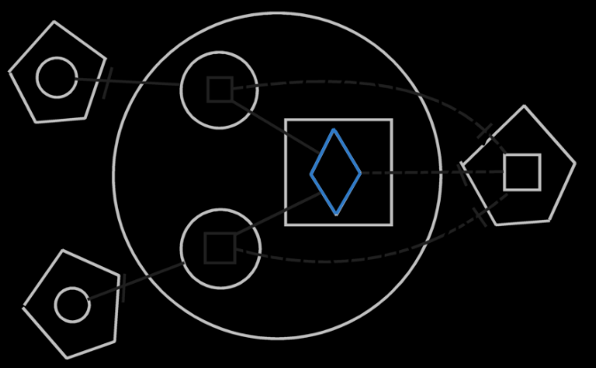

Both pictures express the same physical thing. The first picture displays the objects involved in the method as parameters. The second picture displays the call as a call upon both objects.

Looking at the picture I see, that it just works. It’s a perfect depiction of calling the same method upon multiple objects. This is what exactly displays the interchangability between parameters of a methods and objects whose method is called.

The only thing this doesn’t match yet is: how to express:

- in / out / through / local
- access to privates / access to publics
- optional / required

Especially expressing the distiction between access to privates / access to publics is what I am most concerned about.
But what I have done here in this brainstorm, is solve the main problem. I have, however, broadened the scope already.

<

I just think that I have to make the following topics separate sections:

- Expressing automatic containment of methods in the original way
- Expressing a single call upon multiple objects
- Expression of different parameter types

That will make my life easier.

>

< Brainstorm 2, trying to characterize different parameter types >
Parameters, including the object the method ‘would be called upon’, have different functions, which may affect the way they will be displayed in the diagram:

- in / out / through / local
- access to privates / access to publics
- optional / required

This alters the object’s position in relation to to the method.

< Also consider concrete examples to see if there are positions in which a parameter is put in relation to the method. >

For now I will only consider input parameters.

First I consider one required input parameter to which the method has private access. A call to this method will translate to a call to the object.

< You could find rules, that determine which of the parameters might be most important. And make that the object called upon. But those rules could result in a tie. In that case there must be a way to express you are calling a method on both objects, but that should not be an expression of calling a method, that just references both objects. >

< If you stereotype something as in / out / through / access to privates or just publics or optional or required, it does set certain bounds to the parameters, but doesn’t guarantee the argument is actually used that way. You could define a parameter as throughput, but actually only read from it. In that case the parameter should implicitly be degraded to an input parameter. The class could declare a parameter as access to privates, but the method may only access the public contents. In that case the parameter type is implicitly considered access to only publics. So the implicit parameter type is dependant on the way it is declared and the way it is used. From now on, when I speak of a parameter type, I will be talking about the implicit parameter type. Meaning: an throughput parameter is not only declared as such, but also always used as such. >

<
Throughput could have the following elements:
- affected
- used
- transformed
Affected means that what’s written to the object is not dependant on the original contents of the object.
Affected and used means the same as affected, but also values are read from the object, but the read values do not have an effect on the object itself.
Transformed means that what’s written to the object is dependant on what was first read from the object.
>

< I shall consider the following forms as well:

- One required input parameter with private access
Two required input parameters with public access only
- One required input parameter with private access
One required input parameters with public access only
One local variable with private access
- One local variable with public access
- I just don’t know yet
>

<
Remember: any piece of data used by a method is a parameter of the method.
If a sub object of a parameter is used, this data is considered a parameter itself, because it gets read or is affected.
The usage of the data is analysable in the new computer language, and the usage of the data is important, and determines the data’s position in relation to the method.
>

<

- input
input is not an object that something is done to. It can be considered an object doing something to another object. So it is clearly an actor.
The input parameter always needs to affect something else, but can’t affect itself, or it will be characterized as transformed throughput.
It can be an object called upon.
- output
An output parameter can never be considered an object called upon, because the output parameter only exists after the call, not before.
- affected throughput
A throughput affected parameter can be considered a call to the object, but requires the method to have other parameters as well, that are input or used throughput, that are applied to the affected throughput parameter.
- used throughput
- transformed throughput
- local
the object only exists when the method runs.
In other programming languages a local variable can point to something existing, but in the new computer language, that will be considered input or output of the method.
- access to privates
- access to publics
- optional
- required

>

<
I think you could break it down to even more basic characteristics:

- used to affect another ( = input )
- used to affect itself ( = throughput )
- affected by another ( = ~ output / affected
- produced ( = output )
- temporarily existant

- privates used to affect another
- privates used to affect itself
- privates affected by another
- always used / affected / produced
- not always used / affected / produced

- However, when something is temporarily existant, it might in its temporary existance be affected and used. But then the temporary existant object is passed along to another method as a parameter. The object has a different relation with the other method.

- one time a method runs, something may only be read. Another time it may be read and written to. This changes the implicit position of the object in relation to to the method in each call to the method.

- The thing is: you can both see a method as part of the thing affected, and the method can also be part of the thing that affects something else.

- Always something is the input and something is the output: at least one thing is used, and at least one thing is affected. But the affected thing can also be a new thing
One thing is executed on another. So its data executed on data.
< ~ The method is considered part of both input and output, so it is always considered part of multiple objects. >
When something is output, so didn’t exist yet before, the method can also be a static part of the class, because now there wasn’t an object to begin with, but the method still has something to do with the class.

>
< It matters whether the object is used (read), affected (written), or produced. This alters the object’s position in relation to to the method. >

< A local variable may make the method a static method of a class, instead of a method of an object. >

< What if a method has two parameters, but both the parameters have the same class? You may need to see it as a method static to the class.>

< Brainstorm 1, emphasizing global method and relating it to natural language >
< I need to repeat copy the last paragraph, and then place the pictures of the diagrams in between. >

< That takes case of the section Automatic containment for now, and the section Display of methods in diagrams >

< The sections I planned to do after that, are no more than only exceptions and questionnable situations that need to be cleared up. >

< Before explaining the questionnable situations, I need to brainstorm onward about the possible relations between methods and objects, making a parallel to human language, and then how those. >

< This is not outside the scope of ideas in which I was already working. It just extends the scope of the project a little prematurely. I already involve human language and artificial intelligence in it sooner than originally planned. >

< How does a class get an imaginary reference to each of the methods, that use it? You can’t scan the globe for all methods that hold that class. I don’t know how to solve that yet. >

<

To consider:
- Method expressed as part of a class.
- Methods’ access to private contents of a class.
- The answer may lie in human grammar.
- Method references as opposed to method calls.

>

<
- Method expressed as part of a class.
- The method reference inside the object can not be pointed to, because it does not exist. It is just an imaginary representation in the diagram. So a call to a method will always be a call to the logical target residence of the method. In the diagram the method call will redirect to an imaginary reference to the method, that was placed inside the closest mutual parent. To fill in the parameters of the call to the method, the diamond symbol that represents the call, will contain real object references as parameters, that will point out to the object, that will become the parameter.
But this sucks. In that case you will always invoke some global method, you will never access the method through an object. I do want it expressed, that you access a method through an object.
>

<

The simplest call to imagine is a call to a method, that has one parameter, which is the object the method is called upon. In that case the call could be tied to the imaginary reference to the method, that is visible inside the object the method is called upon.

In a more complex example, a method has two parameters, each a different class. A call to the method requires you to set both parameters. You may call a method upon one of two the objects. That fills one of the parameters of the method. That should imaginarily tie the method call to the that object. But next, the second parameter should also be assigned. Until that is done, the method call is not valid yet. When you’ve assigned the second object for the method, the call is valid. The call may still look like a call upon a method of the first object, but it may also have changes to a call upon the method of the second object, while the first object only appears as a parameter.
But possibly the call will appear as a call to the second object, if the second object is closer in view… but the second object won’t be closer in view… see after the next paragraph.

Methods at first are just global methods. The point of making methods bound to objects, is to structure and group and subdivise the methods, so that they become part of a context. <They also serve as protectors of a class’s data.>
So, even though physically methods are separate entities, logically they seem to be part of a context.
The only addition to methods being separate entities, that flat & structured interchange needs to fulfill, is to have a structured, grouped, subdivised view on the methods.
The parameters of a method make the method part of a class. Physically, the method is a separate entity, with pointers to its classes. The other end of the spectrum, is seeing a method part of all those classes, but leading back to a single method, just like multiple object references lead back to a single object.

The methods simply logically is part of all those classes.
The structured view on things IS to make methods part of the classes the method refer to.
To further structure things, to prevent things from becoming a big mess of wires, is automatic containment of the methods.

A call to an object’s method, well, sorry, but if it involves several objects, the call will just be a call to a global method, that is not part of any object. The call to the global method will be supported by imaginary references, to make things overviewable, just like automatic containment of objects. The call will have references to both of the objects. But the call will lead back to the single entity that is the method, through the use of imaginary references.

What is structured about it, though, is that the method is visible through any object the method could be called upon.

This does look like the only way to go for now, but I do miss pointing that method call to a method, that is inside an object.

I also just can’t see anything in the diagram, that a method has access to the private members of the parameter. You might use access control symbols for that.

Perhaps the concept must be worked out ignoring those two things. And these two things must be considered separately after the main concept is worked out.

Ths concept is automatic containment of methods, so I am in the right section.

> Read over the section, keeping in mind that a call will be to a global method, with imaginary references in between and the call will hold references to the objects.
> I did that. It seems a good way to go.
> When you’ve explained the main concept, you may first display the diagram pictures in the next section ‘Display of methods in diagrams’. Only after that, you may have a clear enough picture, to consider how to see a call to an object, and how to see if the method has private access to the object.

>

< If a method call affects only one object, the method could be seen as part of the object. In that case the method definition is seen as part of the class. The best way to express it in a diagram is the explicit representation of calling a method on an object. > < If a method affects multiple objects, the method does not belong to either of the objects. The method simply belongs to both. A 1 → n relation exists between a method an the objects affected by it. >

< If a method affects multiple objects, the method does not belong to either of the objects. Unless the object is the subject and it is an active sense. Am I creating a link between logic in human sentences, and logic of programs? >

< Noun and a verb. A method is a verb, an object is a noun. A verb is an action, the nouns are the objects. A noun can be used, or affected. Also, the relation of the object can be expressed by a ~ voegwoord <?> (in, op, bij, met…). Can I afperk the possible relations between words, regardless of their meaning, just like computer programs only really express relations between things, regardless of their meaning, and the meaning is just in the imagination of the human being? Perhaps you just have to investigate what possible logical relation an object can have with an action, to be able to see how to couple methods and classes automatically. >

MCLC,

Brainstorm nog maar even door over natuurlijke taal,
maar probeer het niet helemaal te integreren in je concept.
Ga gauw aan de gang met het bekijken van concrete voorbeelden, en het opstellen van een lijst van manieren waarop een object logisch gerelateerd kan zijn aan een method.

JJ

MCLC,

Je mag gewoon niet te lang meer doen over MCLC.
Je moet iets helder definieren en niet te veel details doen, want je moet gewoon door.

JJ

Unreliability of class interface
<>
What if you use one class, you write a method using the class, the method expects the class to have certain methods, and all of a sudden the author of one of these methods, just deletes the method: everybody was using it, everybody thought it was part of the class, and then all of a sudden it’s not there anymore, and all the dependencies do not function anymore.
This is a problem in design, when you make methods so loosely coupled. I don’t want the world to cope with these problems.
The problem is: it is no longer careful system design, when it isn’t just software developers creating systems anymore. Now users can make a method, and all of a sudden a class gets extended. If others start to depend on this method, but it isn’t a very considerate user, that created it, then eventually everybody’s f#&d.
I guess, when you create a method, that uses other methods, you have to be aware, that a method of a class may be authored on a totally different site.
You may be using methods, that don’t have a very reliable source.
You can see in the diagram on what site the method is, compared to the class.
If the method is on the same site as the class, it may be more dependable, than a method from another site.

You could give things a more reliable approach: you host a module, that has classes, and also has methods. The methods and the classes are part of the same module. You rely better on that single module to keep functioning, so when you only use stuff from that module, you’re ok. If you want to use methods from other sites, you’re just going to have to know this site. If you use a method from a vague site, that didn’t even give the method a fixed logical residence, then the method is not reliable. A method can only be reliable, really, when people authoring and using the method have a clear agreement about it.

Methods that aren’t even associated with a module, so methods, that don’t have a fixed logical residence, are less reliable, just like classes without a fixed logical residence. Only objects that have no fixed logical residence are reliable enough, really.

Classes do get extended with methods, if the class is only used inside a method, but you just have to be aware of the site of the method you are using, because that will tell you if the method is going to be reliable.
You are just going to have to be aware of where the stuff you are using comes from. This counts for everything: methods, classes, objects, modules. You just need to be aware of the site you are accessing. You have to do with the whole internet now, so you have to be aware of where the stuff you are using comes from

The functioning of systems, that use other modules, or services offered over a network, depends on good faith, basically. It is like that already: if you use an interface offered over the internet, the functioning of your system depends on the good faith of the other party, hosting it.

Methods of classes are the most reliable, when the class’s and the method’s logical location is inside the same module.
If you use access a method through a class, and that method is hosted elsewhere, you have to know you can strust the other site. If you want more stability and control over the software you are using, you could always host a copy of a dependency, if you are able to copy it, and require more stability and control (this is analogus to having a software component installed on one of your own machines, instead of accessing a remotely running software component).

In diagrams or in text code, you give stuff different colors, depending on what site it is from.

<>

Methods in class reuse with inheritance

Methods in reuse of interfaces

Mutual methods, mutual interfaces?

Method extending a class from another system

When a class is defined in somebody else’s system, and you make a method, that has this class as a parameter, this would immediately extend the class with a new method.
That might be worrying to the ones designing a class.

However, there are a couple of things to keep in mind here.

One: the class did not really get extended. The method is a separate entity. The class just seemed to get extended. Anyone that has access to the new method, could access the method through the class.

< I’m not sure, how I can establish that. I can’t recognize which methods use the class from just the class’s perspective. If I want to know that, all the methods should be registered in that class, or at least in a reference to that class. >

Author & Copyright: Jan-Joost van Zon Date: April 27, 2008 – May 7, 2008 Location: Oosterhout, The Netherlands Status: Under construction

Ideas

Parameter & Class Member Interchange
Any class used directly inside a method, must become a parameter of the method. The method becomes part of any class used by the method.

Certain classes may not be further extended.
This may be in the way of this flat & structured interchange.
You might create a derived class in that case, if the original class can not be extended with methods.
But… a class doesn’t have any methods anymore.

You also don't want the class Integer to be extended with
any method that uses integers.
Actually, the method will only become part of the classes that it directly uses. When the method uses submembers of the classes, the method does not become part of the classes of the submembers.

This needs to be further thought through.

You can however stop a parameter from creating an extra member in its class, but by default the class gets extended.

<~>The globality<~> can get a lot of overloaded method names, but this was already the case in languages such as C++. All the methods of all classes were already reachable globally.

The method’s name is the same in all classes. But methods can be overloaded. They can even be overloaded having the same signatures, because in the diagram they are different symbols, and can be reached separately regardless of their name.

In text code this will look like a method being reachable through any object that has a class that is a parameter of the method.

<> Perhaps the way the object is used by the method, creates a stereotype, analogus to our human language grammar. Onderwerp, leidend voorwerp, meewerkend voorwerp en allerlei bijwoordelijke bepalingen, might be determined by the fact if a parameter is read, written, read and written, only transferred to other methods, state written, state read, member written, member read… <>

In diagrams this will look like: when you create a method within a class, the neareast globality gets a method too. A class line is drawn between the global method and the class method. When you add a parameter to the method, the class of the parameter also gets the method. That basically places the object (the parameter) inside the method and automatically places the new method inside the object. If you assign a class to the parameter. The class gets the new method. The methods are all class-tied to the global method.

Perhaps it would also work like this: automatic containment is applied to the method. When a method uses a certain class, the method is ~ placed inside at the topmost container… how did that work again? So the method doesn’t become global… huh? How did automatic containment work again?
So the method does not become global, but it becomes part of the biggest whole.

A problem here, is that the interface of a class can change very suddenly. When you define a method, and simply give the method a parameter of a class, the class gets extended straight away.
That may cause of problem, when it is important a class has a certain interface. I’m not sure how that will be solved, yet.

The data interface of the class doesn’t change that suddenly.
The method interface does. I guess, if you use an interface it is only for a couple of possible purposes:
(I’m not sure this list is complete)
- Support a sure set of members
- Participate in existing systems
- Derived from another class
If you want to support an interface something else has defined, you will support all its methods, through that interface. But what if that something else’s interface changes too? Then it does. You don’t expect a program to all of a sudden change, so the interface should be staying the same.

What if another system uses a class as a parameter? Will that extend the class defined elsewhere? No, a class defined elsewhere is probably protected agains class extension with methods. But within your own system the external class could become a derived class that does have extended methods.

There should be mechanisms that limit class extension with methods that have the parameter as the class. Access control should be that mechanism. Access control is also the mechanism, that limits change of containment structure. Yeah, access control is the key.

-----

When you can't change a class's definition,
should a derived class be automatically created,
in order for the method to be added to the class?

> So even, when a class is inside another globality,
and you create a method, that uses that class,
the class SEEMS to get extended, but only when the method is accessible.
Huh?

MCLC,

Je moet gewoon net zoals bij AC eerst het hoofdidee uitwerken, en daarbij alle dingen, die het moeilijker maken negeren en bewaren voor later.

Dan zie je dat wel weer terug in de uitleg, net zoals bij AC, dat ik een beetje op dingen terug moet komen. Ik weet niet of dat bij MCLC ook weer gebeurt. Maar is dat eigenlijk zo slecht? Als ik het mezelf op die manier moet uitleggen, is dat dan ook niet de beste uitleg naar anderen toe?

JJ

